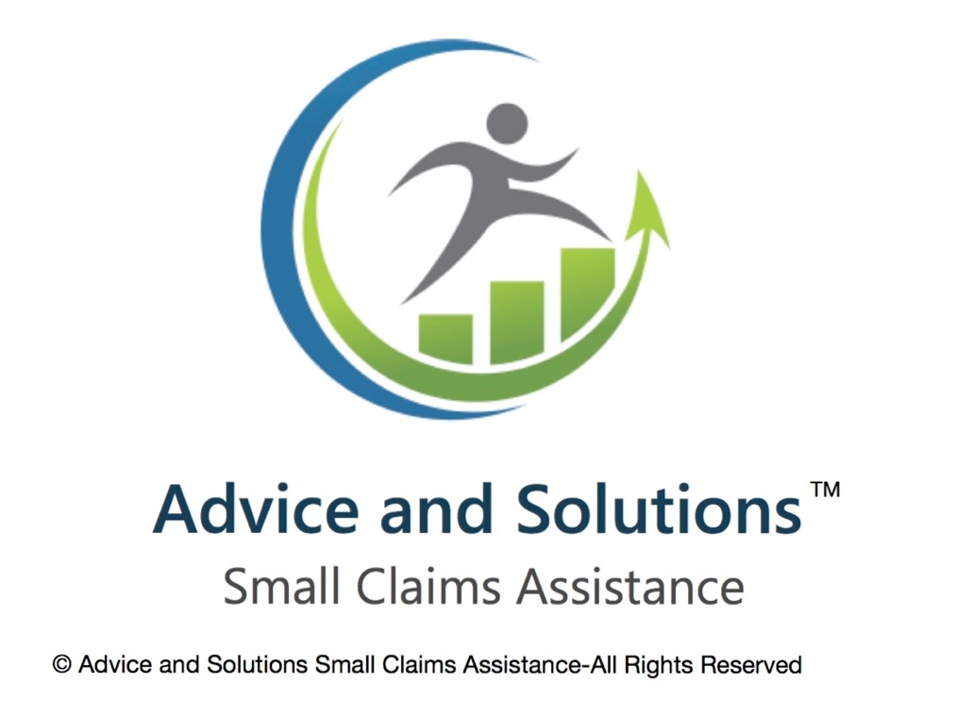

**Pre-Claim Preparation Guide**

To prepare for a small claim in the UK (England and Wales), there are a number of key steps you should take before formally starting the claim. This guide covers the following:

1. Understand if Your Case Qualifies

2. Try to Resolve It First (Pre-Action Protocol)

3. Collect & Organize Your Evidence

4. Calculate the Amount You're Claiming

5. Check the Defendant’s Correct Details

6. Consider the Costs and Risks

1. **Understand if Your Case Qualifies**

In the UK, small claims are generally for disputes where the amount of money involved is relatively low, and the process is simplified to make it easier for individuals to represent themselves without needing a lawyer.

For a case to qualify for small claims court, it needs to meet a few criteria:

**1. Value of the Claim**

* **England and Wales**: The claim must be for £10,000 or less.
* **Scotland**: The limit is £5,000 for simple cases, but some cases can go up to £100,000.
* **Northern Ireland**: The limit is £3,000 for most small claims.

**2. Type of Claim**

Small claims typically involve:

* **Money owed (debt recovery)**: For example, if someone hasn’t paid for goods or services.
* **Property disputes**: For example, if you are trying to recover money for damage caused to your property.
* **Contract disputes**: If a business or individual hasn’t upheld their part of an agreement.
* **Personal injury claims**: Small claims for personal injury are allowed, but they can only be for minor injuries (up to £1,000 in compensation).

**3. Nature of the Case**

Small claims are intended for relatively straightforward cases, so they generally involve:

* **Clear and simple evidence**: You can prove your case without too much complexity.
* **Not requiring expert evidence**: For example, you don't need a lot of professional testimony.

**4. Who You Can Sue**

* You can take a case against individuals, businesses, or other entities, as long as the issue falls within the small claims criteria.
* Claims against the government or local authorities are typically excluded from small claims.

**5. Exclusions**

Some claims are **not eligible** for small claims court, including:

* Claims for defamation (libel or slander).
* Some types of personal injury claims, especially those involving serious injuries.
* Claims involving land or real estate disputes (unless it's a tenant issue in some cases).

**6. Where to Start**

You can start a small claim by:

* **Online**: The UK government provides an online service to start a small claim.
* **By post**: You can also use paper forms to apply to the court.
* **In person**: Some courts allow you to file claims in person.

**Process:**

* **Filing a Claim**: You will need to fill out a claim form, pay a fee, and send it to the court.
* **Court Hearing**: If the case isn’t settled out of court, a hearing will be arranged. Generally, a judge will make the decision, and you’ll receive a ruling.

**Important Considerations:**

* **Costs**: You may have to pay a fee to file the claim, though you can apply for a fee waiver if you're on a low income.
* **Enforcement**: If you win your case and the other party doesn't pay, there are enforcement actions you can take (like requesting the court to seize assets), but this can come with additional costs.

**2. Try to Resolve It First (Pre-Action Protocol)**

The **Pre-Action Protocol** for small claims typically refers to the procedures a party must follow before filing a small claims court case, particularly in jurisdictions like the UK or certain US states. This protocol encourages parties to try to resolve the issue outside of court, saving time, money, and court resources.

Here’s an outline of what the pre-action protocol generally involves:

**1. Try to Resolve the Dispute Amicably (Alternative Dispute Resolution - ADR):**

* **Contact the Other Party**: Before considering legal action, it's recommended to communicate directly with the person or organization you're in dispute with. This could be through a phone call, email, or letter.
* **Negotiation**: You may try to negotiate a settlement or agreement that resolves the issue.
* **Mediation**: If direct communication doesn’t work, you can consider using a neutral third party (mediator) to help resolve the dispute.

If the dispute involves a consumer and business, certain jurisdictions might require you to try an **Alternative Dispute Resolution (ADR)** process, which can include mediation.

**2. Send a Formal Letter Before Action:**

* A **Letter Before Action** (often called a demand letter or notice of claim) is an official document sent to the other party outlining your grievance, the amount owed (if applicable), and the steps you expect them to take to resolve the matter.
* The letter should include:
  + A clear explanation of the dispute
  + Any supporting evidence (e.g., invoices, contracts, or photographs)
  + A reasonable deadline (usually 14-30 days) for the other party to respond or settle the matter
  + A warning that if no resolution occurs, legal action may be pursued.

**3. Evidence Gathering:**

* Ensure you have all the evidence needed to support your claim. This could include receipts, contracts, communication records, and any relevant documentation that backs your case.

**4. Failure to Resolve:**

* If the other party does not respond or refuses to settle the dispute after receiving the letter, you may proceed with filing a claim in small claims court.
* Ensure that you have kept a record of your attempts to resolve the dispute. This will show the court that you tried to solve the issue without going to trial, which is typically required under the Pre-Action Protocol.

**5. Filing the Claim:**

* If settlement negotiations fail, you can begin the formal court process by filing your claim. In small claims, this process is generally straightforward, and many jurisdictions allow you to file claims online.
* You’ll need to pay a filing fee, which varies depending on the amount of the claim.

**6. Court’s Role in Encouraging Settlement:**

* In some cases, the court may require both parties to attend a hearing or mediation session before the trial. They may even actively encourage settlement during the legal process.

**Key Benefits of Following the Pre-Action Protocol:**

* It can often lead to a resolution without needing to go to court, which can save both parties time and money.
* It demonstrates to the court that you attempted to resolve the issue without litigation, which might be favourable if the case ends up going to trial.
* Many courts require evidence of these efforts to proceed with a claim.

**3. Collect & Organize Your Evidence**

In the UK, when preparing to take a claim to small claims court, it’s essential to collect and organize your evidence properly. This will help you present your case clearly and increase your chances of success. Here’s how you can do that effectively:

**1. Document Everything**

* **Emails/Letters/Correspondence:** Gather all communications related to your claim. This includes emails, text messages, or letters exchanged with the other party. These documents can serve as proof of your efforts to resolve the dispute or as evidence of what was agreed upon.
* **Invoices/Receipts:** If your claim involves financial matters (such as a debt or a breach of contract), make sure to have all relevant invoices, receipts, or payment records.
* **Contracts/Agreements:** If there is a contract involved, keep a copy of it. This includes signed agreements, terms and conditions, or any other documents that outline what was agreed upon.
* **Photos or Videos:** If the dispute involves physical damage (e.g., defective goods, property damage), photographs or videos can be vital in proving your case.
* **Bank Statements:** If you’re claiming non-payment, bank statements showing transfers, payments, or lack thereof will be helpful.

**2. Organize Your Evidence**

* **Create a Timeline:** Having a clear timeline of events can help present your case in a coherent manner. This might include when the contract was signed, when payments were made, or when damages occurred.
* **Organize Documents Chronologically:** Arrange your evidence in the order in which the events occurred. This will allow the judge to easily follow the progression of your case.
* **Label Evidence:** Label each piece of evidence clearly with a description of what it is and how it relates to the case (e.g., "Email from Defendant dated 1st March 2023 confirming the agreement").
* **Index and Paginate:** Create a numbered index or table of contents for your documents. Number each page for easy reference during the hearing.

**3. Prepare a Witness Statement**

* If you have witnesses to the event or transaction, their testimony can be valuable. A **witness statement** should outline what they saw or know, when it happened, and why it’s relevant to your case. Have the witness sign the statement and make sure it’s dated.

**4. Check the Rules for Submitting Evidence**

* The **small claims court** in the UK generally allows you to submit evidence before the hearing, often through the online platform or by post. Be sure to submit your evidence as required, and stick to deadlines.
* You’ll also need to provide a **brief summary** of the evidence you’re presenting and how it supports your claim.

**5. Be Clear and Concise**

* Avoid including irrelevant or excessive evidence. Only present what directly supports your case. Organize your evidence logically, and ensure that it is easy to understand and reference.

By collecting and organizing your evidence properly, you’ll make the process of presenting your case much smoother and increase the likelihood of a successful outcome.

**4. Calculate the Amount You're Claiming**

In the UK, the **amount you're claiming** in small claims court refers to the total value of your claim, which typically includes:

1. **The main sum you're claiming** (the money owed or value of the goods or services).
2. **Interest** (if applicable, based on the amount owed and the time it's been overdue).
3. **Court fees** (if you're successful in your claim, the other party may have to pay your court fees).
4. **Other costs or expenses** (for example, if you've paid for repairs or have incurred losses related to the issue).

**Step-by-Step Breakdown:**

1. **Claim the main amount**: This is the sum of money you're owed, whether it's for unpaid goods, services, or contractual breach. For example, if someone owes you £500, then £500 is the amount you're claiming.
2. **Add interest (if applicable)**:
   * If the debt is overdue, you can claim interest on the sum from the date it was due. The current rate for interest on late payments is **8% per annum** (from the date the money was due until it is paid).
   * Example: If you're claiming £500, and it’s overdue for 3 months, you can calculate the interest on that amount for the period.
3. **Include court fees**: If you decide to proceed with a claim in a small claims court, you'll have to pay a fee to start the claim, which depends on the amount you're claiming. These are the general fees:

* Claims up to£300: £35
* Claims between £300 and £500: £50
* Claims between £500 and £1,000: £70
* Claims between £1,000 and £1,500: £80
* Claims between £1,500.01 to £3,000 £115
* Claims between £3,000.01 to £5,000 £205
* Claims between £5,000.01 to £10,000 £455
* Claims between £10,000.01 to £20,000 5% of the claim
* Claims of more than £200,000 £10,000

1. **Other costs**: You may also be able to claim for other reasonable expenses you have incurred due to the issue (like travel expenses or costs of hiring someone to assist with the claim).

**Example:**

If you're claiming for £500 owed for goods, and the debt has been overdue for 3 months:

* **Claim amount**: £500
* **Interest for 3 months**: You calculate 8% annual interest on £500 over 3 months. (8% / 12 months) * 3 = 2% of £500 = £10.
* **Court fee**: If the claim is under £500, the court fee would be £50.
* **Total claim**: £500 (owed) + £10 (interest) + £50 (court fee) = **£560**.

**5. Check the Defendant’s Correct Details**

To check the defendant's correct details for a small claims case in the UK, you need to ensure that all the information is accurate so that the claim can be processed properly. Here's a quick guide on how to go about verifying the defendant's details:

**1. Check the Claim Form**

When you start a small claims case, the **claim form** (Form N1) requires you to enter the defendant's full name, address, and details of the claim. If you're unsure of the defendant's address, try to verify it through:

* The defendant's business address (if it's a company).
* Contacting the defendant directly to confirm.
* Looking through official documents, contracts, or agreements with the defendant where their details are listed.

**2. Use the County Court Judgment (CCJ) Register**

If you're concerned that the defendant might have a history of not paying debts, you can search for their name in the **Register of County Court Judgments** (CCJ). This will show if the defendant has any outstanding judgments against them.

You can access the CCJ register online, and there may be a small fee for this service.

**3. Check Companies House (for businesses)**

If the defendant is a business, you can search the **Companies House** online register to find accurate details, such as the business name, address, company directors, and more.

* Go to the Companies House website: www.gov.uk/government/organisations/companies-house
* Enter the company name or number to get details.

**4. Use the Land Registry (for Property Address)**

If you know the defendant owns property, you can use the **Land Registry** to confirm their ownership details. This is particularly useful if you're unsure about their address.

* Visit the Land Registry website: www.gov.uk/search-property-information-land-registry

**5. Check Online Databases**

There are a number of online services that provide people search tools where you can find a person’s address or other details based on public records.

**6. Solicitors or Court Help**

If you're struggling to verify the defendant's details, you may want to contact a solicitor or the court to ask for assistance, especially if you cannot find an address or correct details.

**7. Correcting Information**

If you’ve filed the claim and later realize you have made an error in the defendant’s details, you’ll need to inform the court and correct the details as soon as possible. You can typically do this by contacting the court directly.

**6.Consider the Costs and Risks**  
In the UK, small claims court is a process designed to help individuals resolve disputes without the need for expensive legal proceedings. However, even though it is intended to be relatively straightforward, there are still costs and risks involved in pursuing a claim. Here's an overview:

**Costs of Small Claims in the UK**

1. **Court Fees:**  
   The fees for filing a claim in a small claims court are relatively low but vary depending on the amount of money you're claiming. As of recent information:

* Claims up to£300: £35
* Claims between £300 and £500: £50
* Claims between £500 and £1,000: £70
* Claims between £1,000 and £1,500: £80
* Claims between £1,500.01 to £3,000 £115
* Claims between £3,000.01 to £5,000 £205
* Claims between £5,000.01 to £10,000 £455
* Claims between £10,000.01 to £20,000 5% of the claim

Claims of more than £200,000 £10,000Note: **Money claims** typically come with a fixed fee structure, but the court may charge for additional services such as issuing warrants or requests for judgments.

1. **Legal Representation:**  
   You are generally not allowed to have legal representation in small claims court, unless there are exceptional circumstances. This is because the process is designed to be more accessible and informal than higher courts, so most people represent themselves (known as "litigants in person").

**Solicitor’s Fees:** If you choose to seek legal advice before the claim or assistance with preparation, the cost for solicitors varies. While you are not permitted to have a solicitor in court, some might offer "fixed-fee" consultations for preparation.

1. **Other Costs:**
   * **Expert Witnesses:** If you need to use expert witnesses to support your claim (e.g., a surveyor or engineer), their fees can be costly.
   * **Travel and Postage:** If the court requires documents to be delivered in person, you may incur additional costs for travel, postage, or administrative tasks.

**Risks of Small Claims in the UK**

1. **Losing Your Case:**  
   If you lose your case, you generally don’t have to pay the other party’s legal fees because legal representation is not normally allowed in small claims. However, you might still be ordered to pay the court fees of the other party, especially if you fail to provide sufficient evidence.
2. **Enforcing Judgment:**  
   If you win the case but the other party doesn’t pay the judgment amount, you might face difficulty enforcing the decision. While there are ways to force payment (e.g., by taking money directly from their wages or bank accounts, or using bailiffs), this process can take time and incur additional costs.
3. **Time and Stress:**  
   While the process is designed to be quicker and easier, taking a claim to court still involves time and effort. Preparing your case, attending hearings, and dealing with any challenges can cause stress, particularly if the case becomes complex.
4. **Risk of Counterclaim:**  
   The defendant may file a counterclaim, which means that you could end up having to defend a claim yourself in addition to the original issue. If the counterclaim is successful, it could increase the costs and liabilities for you.
5. **Possible Damaged Relationships:**  
   If you're suing an individual or business you have an ongoing relationship with, such as a supplier or customer, a court action could damage that relationship, which might have long-term implications beyond the financial settlement.
6. **Inability to Claim Costs:**  
   Unlike in higher courts, in small claims court, you typically cannot recover the costs of your time or any personal inconvenience caused by the dispute. You are only able to claim certain costs (e.g., travel expenses, expert witness fees) if they are directly related to the case.

**Conclusion:**

While the small claims court offers an affordable and relatively informal route for resolving disputes, it comes with costs (fees, time, and potential for additional expenses) and risks (e.g., enforcement difficulties, counterclaims). If the claim is straightforward and the amount involved is manageable, it can be a good option, but it’s important to carefully assess the merits of your case and whether you’re prepared for the process.