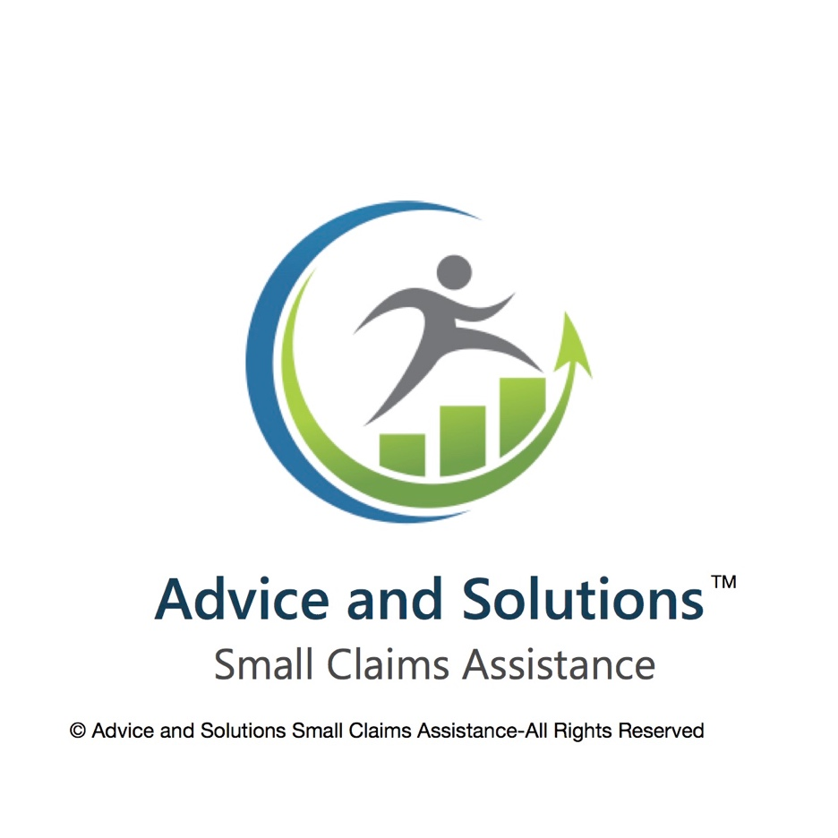

**Terms and Conditions**

**Introduction**

These terms and conditions apply between you, the user of this website (including any sub domains unless expressly excluded by their terms and conditions), and Advice and Solutions Small Claims Assistance, the owner and operator of this website. Please read these terms and conditions carefully, as they affect your legal rights. Your agreement to comply with and be bound by these terms and conditions is deemed to occur upon your first use of the website. If you do not agree to be bound by these terms and conditions, you should using this website immediately.

​

In these terms and conditions, the user or the user's means any third party that accesses the website is not either (i) employed by Advice and Solutions Small Claims Assistance and acting in the course of their employment or (ii) engaged as a consultant or otherwise providing services to Advice and Solutions Small Claims Assistance and accessing the website in connection with the provision of such services.  
  
**Intellectual property and acceptable use**

* Unless uploaded by users, all content included on the website is the property of Advice and Solutions Small Claims Assistance, our affiliates or other relevant third parties. In these terms and conditions, content means any text, graphics, audio, video, software, data, compilations, page layout, underlying code and software and any other form of information capable of being stored in a computer that appears on or forms part this website, including any content uploaded by users.  By continuing to use the website you acknowledge that such content is protected by copyright, trademark data base rights and other intellectual property rights. Nothing on this site shall be construed as granting, by implication, estoppel, or otherwise, any license or right to use any trademark, logo or service mark displayed on the site without the owners prior written permission.
* You may, for your own personal, non-compliance use only, do the following;  
  (a) retrieve, display and view the content on a computer screen
* You must not otherwise reproduce, modify, copy, distribute or use for commercial purposes any content without the written permission of Advice and Solutions Small Claims Assistance.
* You must not otherwise use the website for any of the following purposes;
* (b) in any way which causes or may cause, damage to the website or interferes with whole of) the website including, but not limited to, any products and/or services available. These terms and conditions shall continue to apply to any modified version of the website unless it is expressly stated otherwise.   
    
  **Limitation of liability**

**​**

* Nothing in these terms and conditions will: (a) limit or exclude our or your liability for death or personal injury resulting from our or you negligence, as applicable (b) limit or exclude our or your liability for fraud or fraudulent misrepresentation; or (c) limit or exclude any of our or your liabilities in any way that is not permitted under applicable law.
* To the extent that the website and content are provided free of charge, we will not be liable to you for any loss or damage of any kind.
* We will not be liable to you in respect of any loss arising out of events beyond our reasonable control.
* To the maximum extent permitted by law, Advice and Solutions Small Claims Assistance accepts no liability for the following;  
    
  (a) any business losses, such as lost profits, income, revenue, anticipated savings, business, contracts, goodwill or commercial opportunities;  
  (b) Loss or corruption of any data, database or software;  
  (c) any special, indirect or consequential loss or damage.

​

**General**

**​**

* You may not transfer your rights under these terms and conditions to any other person. We may transfer our rights under these terms and conditions where we  reasonably believe your rights will not be affected.
* These terms and conditions may be varied by use from time to time. Such revised terms will apply to the website from the date of publication. Users should check the terms and conditions regularly to ensure familiarity with the then current version.
* These terms and conditions together with the privacy policy contain the whole agreement between the parties relating to its subject matter and supersede all prior discussions and arrangements that might have taken place about the terms and conditions. **​**
* The contract (rights of third parties) Act 1999 shall not apply to these terms and conditions and no third party will have any legal right to enforce or rely on any provision of these terms and conditions
* If any court or competent authority finds that any provision of these terms and conditions (or part of any provision)is invalid, illegal or unenforceable, that provision or part-provision will, to the extent required, be deemed to be deleted, and the validity and enforce-ability to the other provisions of these terms and conditions will not be affected.
* Unless otherwise agreed no delay, act or any other, right or remedy.
* This agreement shall be governed by and interpreted according to the Law of England and Wales and all disputes arising under the Agreement (including non-contractual disputes or claims) shall be subject to the exclusives jurisdiction of the English and Welsh Courts.