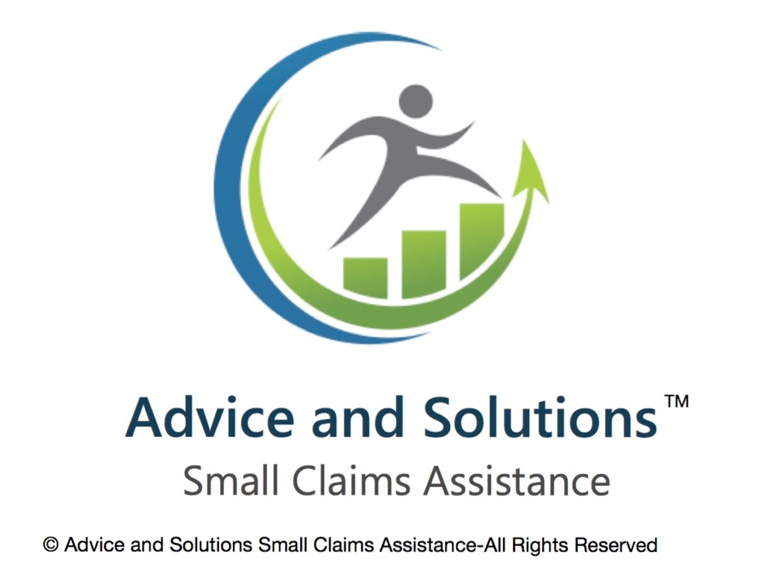

**Claim form N1-getting it right**

The N1 form is used for making a claim in the County Court in England and Wales, specifically for small claims or money claims. If you are completing the N1 Small Claim form, here’s a breakdown of the sections covered in this guide:

1. Claimant and Defendant Details

2. Claim Amount

3. Brief Statement of the Claim

4. Details of the Claim

5. Particulars of the Claim

6. Claimant’s Signature

7. Additional Information

**1. Claimant and Defendant Details**  
  
In a UK Small Claims Court case, the claimant and defendant are the two main parties involved in the legal dispute. Here’s a breakdown of each:

**1. Claimant:**

The **claimant** is the person or business that is bringing the case to court. They are making a claim for money or some other remedy, such as the return of property or fulfilment of a contract.

**Key points about the claimant:**

* The claimant is the one seeking a legal solution or compensation.
* The claimant will complete and submit a **Claim Form** (Form N1) to start the case.
* The claimant must provide evidence to support their claim, such as invoices, contracts, photographs, or witness statements.
* In some cases, the claimant may be representing themselves (i.e., acting as a **litigant in person**), though they may also have legal representation.

**2. Defendant:**

The **defendant** is the person or business being accused or sued by the claimant. The defendant is defending against the claim made by the claimant, and their role is to either dispute the claim or provide a defence.

**Key points about the defendant:**

* The defendant will receive a **Claim Form** and will need to respond by filing a **Defence** (Form N9) within a specific time period (usually 14 days from receiving the claim form).
* The defendant can admit the claim and agree to pay or settle, or they can dispute the claim and provide their version of events.
* The defendant may also represent themselves or have a legal representative (e.g., a solicitor).

**What Happens Next?**

After the claimant and defendant provide their details and files, the court will review the case and may:

* Send the claim to the defendant.
* Organize a hearing or mediation if required.
* Issue a judgment based on the evidence provided.

**Key Forms for Small Claims:**

* **Form N1** – Claim Form.
* **Form N9** – Defence Form (for the defendant to respond).
* **Form N180** – Directions Questionnaire, used to decide if a hearing is necessary.

In a **Small Claims** case, the amount being claimed is usually up to £10,000, though there are some exceptions for personal injury claims. The court process is generally designed to be straightforward and accessible, allowing individuals to represent themselves without needing a solicitor.

**2. Claim Amount**  
To file a claim for a small claim in the UK, you need to use the **Claim Form (N1)**. This form is used to start a claim in either the County Court or the High Court, depending on the value of the claim. If it's a small claim, the County Court is typically where you will file it.

Here’s a general overview of the steps for using the N1 Claim Form:

**1. Get the N1 Form**

You can download the **N1 Claim Form** from the official UK Government website, or you can get a paper copy from your local County Court.

**2. Complete the Form**The N1 form will ask for several details, including:

* Your details (the claimant)
* The defendant’s details (the person or business you're suing)
* The nature of the claim (why you're taking legal action)
* The amount you are claiming
* Any interest you're claiming
* What you want the court to do (e.g., order the defendant to pay the claim)

**Example of information needed:**

* Your name and address
* Defendant's name and address
* Amount being claimed (e.g., the money you are owed)
* A brief description of the claim
* Any supporting evidence (such as contracts, receipts, or invoices)

**3. Submit the Claim**

Once the form is completed, you will need to:

* **Pay the court fee:** This depends on the amount you are claiming. For small claims, it is typically a relatively low fee.
* **Submit the form:** You can submit the form online or in person at your local County Court

**4. Serve the Claim**

Once the form is submitted and the court issues a claim, you’ll need to serve the defendant with a copy of the claim form. This is the formal process of notifying the defendant about the legal action.

**Fee Guide (for small claims)**

For claims in the **small claims track** (which is typically for claims under £10,000), the court fees are as follows:

* Claims up to£300: £35
* Claims between £300 and £500: £50
* Claims between £500 and £1,000: £70
* Claims between £1,000 and £1,500: £80
* Claims between £1,500.01 to £3,000 £115
* Claims between £3,000.01 to £5,000 £205
* Claims between £5,000.01 to £10,000 £455
* Claims between £10,000.01 to £20,000 5% of the claim
* Claims of more than £200,000 £10,000

**3. Brief Statement of the Claim**

A **Brief Statement of the Claim** in a **N1 Small Claims** form (used in the UK) is a concise summary of the case that explains the nature of the claim and why the claimant believes they are entitled to the money or remedy being sought.

In the N1 form, the statement should outline:

1. **The Claimant's position**: Who you are and your role in the case (e.g., individual, business, etc.).
2. **The Defendant's position**: Who the defendant is (their name and role).
3. **Nature of the Claim**: A brief description of the issue or dispute (e.g., non-payment, breach of contract, faulty goods, etc.).
4. **Amount claimed**: The amount of money you are seeking (including any interest, costs, etc.).
5. **Relevant facts**: Key facts that support your case, such as dates, amounts, and any actions taken (e.g., attempts to resolve the matter).

**Example:**

"The claimant is seeking £500 in unpaid rent from the defendant for the period between 1st January 2023 and 31st March 2023. The defendant has failed to pay the rent as per the tenancy agreement, despite reminders sent on 15th February and 1st March 2023. The claimant requests payment of the outstanding amount along with interest at 8% per annum from the due date until the date of payment."

**4. Details of the Claim**

In the UK, **Claim N1** is the **Claim Form** used to start a small claims case in the County Court. It’s a standardized form that initiates legal action, such as a claim for money or other small civil disputes. The small claims track typically handles claims under £10,000 in England and Wales.

Here’s a breakdown of the details typically included in **Claim N1**:

**1. Details of the Claimant**

* **Name**: The person or entity bringing the claim.
* **Address**: The address where the claimant can receive legal correspondence.
* **Contact Details**: Phone number or email.

**2. Details of the Defendant**

* **Name**: The person or entity being sued.
* **Address**: The defendant's address.
* **Contact Details**: (Optional)

**3. Particulars of the Claim**

* **Claim details**: A brief summary of the claim. This section explains what the claim is about, for example, a breach of contract, unpaid debt, or damage to property. You need to provide specific details and dates.
* **Amount of money** being claimed, if applicable.

**4. Court Details**

* You will need to indicate which court you are submitting the claim to. The court may be determined by your location or the defendant’s location.

**5. Statement of Truth**

* The claimant must sign a statement saying that the information provided is accurate to the best of their knowledge. This is a declaration that the details you have provided are true.

**6. Legal Representation**

* If you are representing yourself (which is common in small claims cases), you should indicate that. If you have a solicitor, the details should be provided.

**7. Fee**

* There is a fee to file the Claim N1 form. The amount varies depending on the value of the claim, typically ranging from £35 to £455.

**5. Particulars of the Claim**

In the UK, the **N1 Claim Form** is the document used to initiate a small claim in the County Court. It’s used when you want to bring a claim for money or other relief, such as specific performance of a contract or the return of goods. The form can be used for claims of any size but is typically associated with small claims (under £10,000 in value).

Here are the main **particulars of the claim** section you will need to fill out when completing the N1 form:

**Particulars of the Claim:**

This is where you provide a clear and concise summary of your case. It should include the following:

1. **The nature of the claim**:
   * Briefly state what your claim is about (e.g., breach of contract, unpaid debt, faulty goods, personal injury, etc.).
2. **Key facts**:
   * List the facts that support your claim. These are the events, actions, or omissions that led to the dispute.
   * Be clear and concise – do not include unnecessary details. You may reference documents if relevant (e.g., invoices, contracts, emails, etc.).
3. **The amount of money being claimed (if applicable)**:
   * If your claim is for a specific amount of money, specify how much and the basis for the calculation. For example, if it’s unpaid rent, include the overdue amount and any interest.
   * If the claim is not for money (e.g., returning goods or specific   
     performance), be specific about what you want the court to order.
4. **Any relevant dates**:
   * Include important dates that support your claim (e.g., when the contract was signed, when the breach occurred, or when the debt became due).

1. **Summary of the remedy you seek**:
   * Explain what you want the court to do. This could be:
     + Ordering the defendant to pay money
     + Returning goods
     + Ordering specific performance of a contract (e.g., completing work)
     + A declaration of rights (e.g., that you have ownership of something)
2. **Legal grounds for the claim**:
   * This is a brief explanation of the legal basis of your claim (e.g., breach of contract, negligence, consumer rights, etc.).

**Example of Particulars of the Claim:**

Let's say you are claiming for an unpaid debt from a client:

**Claim for Unpaid Debt**:

1. **Nature of Claim**: The claimant is seeking payment of £1,000 for services rendered under a contract signed on 1st March 2023. The defendant has failed to pay the agreed sum despite several reminders.
2. **Facts**: On 1st March 2023, the claimant and defendant entered into a contract for graphic design services. The defendant agreed to pay £1,000 upon completion of the work. The claimant completed the work on 15th March 2023, but the defendant has failed to make any payment despite being sent three reminders (on 20th March, 5th April, and 10th April 2023).
3. **Amount of money claimed**: £1,000, being the unpaid balance for the services provided.
4. **Remedy sought**: The claimant seeks an order for the defendant to pay the £1,000 plus any applicable interest and court fees.
5. **Legal grounds**: The claimant’s claim is based on the breach of contract, as the defendant has failed to pay the agreed sum

**Additional Tips:**

* **Be clear and concise**: The Particulars of the Claim should provide a short and clear explanation of why you are bringing the claim and what you want from the court.
* **Supporting Documents**: If you have documents that support your claim (e.g., invoices, emails, contracts), you will need to provide copies with your claim.
* **Amount Claimed**: If the claim involves an amount of money, be sure to specify whether you are claiming interest
* **Be accurate**: The court will use the Particulars of the Claim to assess your case, so make sure the information is accurate.

**6.Claimant’s Signature**

In the context of the UK Small Claims Court, the **Claimant’s Signature** refers to the signature of the person making the claim (the **claimant**) on the claim form.

The **N1 form** is the official document used to start a claim in the County Court in England and Wales, including small claims. This form is used for a variety of claims, including contractual disputes, unpaid debts, and damage to property, among others.

Here's a breakdown of where the **Claimant’s Signature** comes into play on the N1 form:

1. **Claimant's Information**: You'll need to provide personal details, including your name and contact information, as the claimant. This section also asks for the defendant's information.
2. **Claim Details**: You'll need to explain the nature of your claim, such as the issue, the amount you're seeking, and the reason behind the claim.
3. **Signature**: At the end of the form, there is a section for the **Claimant’s Signature** (usually on the last page of the form). By signing, you are affirming that the information in the form is accurate and that you are submitting the claim in good faith. It’s essentially your declaration that you are bringing this claim to court, and you are requesting that the court hears the case.
4. **Date**: You’ll also be asked to provide the date when you sign the form.

If you're filing a claim online (using Money Claim Online), you might not need to physically sign the form. Instead, you'll typically click a box to confirm that the information is correct and that you're submitting the claim.

**7. Additional Information**

### **Additional Information Form:**

In some cases, after submitting the N1 form, the court may ask for additional information, which could be provided on supplementary forms or additional documents. For example:

* **N9**: If you're responding to a claim, you’ll need the N9 form.
* **N244**: If you want to make an application to the court to change the details of the claim or other procedural changes.
* **Statement of Truth**: You will need to sign one of these confirming the accuracy of your details.